Transceiver Architectures

Termonology:
WPAN: Wireless Personal Area Network (Bluetooth)
TSCT: Two Step Conversion transmitter
DLT: Direct Launch Transmitter
DRFS:
PA: Power Amplifier
HW: Hardware
SW: Software
FDMA: Frequency Division Multiple Access
TDMA: Time Division Multiple Access
CDMA: Code Division Multiple Access

Overview:
A transceiver consists of a transmitter, receiver, and any additional circuits that contribute to the devices functionality.
An Access method determines the way by which multiple users may physically share (access) common sets of communication channels. Types of access methods include FDMA, TDMA, and CDMA.
In RF communication, a channel can be paired. A paired communication channel consists of two distinct RF channels, each at a different frequency. With one devoted to transmitting only, and the other to receiving only. These operate on a time-sharing basis.
When paired channels transmits and receives simultaneously, the transceiver is operating in full duplex mode.
A transceiver that functions on un-paired channels operates in simplex mode.

RF System Major Components:
- Transmitter: Takes information, generates an RF signal embedded into this information, boosts the RF signal to a suitable power level for transmission, routes RF signal to antenna port.
- Transmit Antenna: A mediator between the transmitter and transmission medium. Ensures all RF signal power is present at port, leaves transmitter, enters transmission medium, and propagates in desired direction.
- Transmission channel: Medium that separates the Transmitter and the Receiver. This can be the atmosphere, vacuum, solids, or liquids. While propagating through this medium, the RF signal loses strength.
- Receiver Antenna: A mediator between the transmission medium and the receiver. Captures as much of the Incident (weaker) RF signal as possible, and conveys this to the receiver.

Transmitter Functional Blocks:

Backend
Exciter
Power Amplifier

Power Amplifier: The amplifier chain working at final RF frequency with input power levels of the order of + 10dBm and higher. The PA includes the final RF amplifier, circuits for sampling and cleaning the output RF power, and performing power control.

Exciter: The amplifier chain with input power level of the order of magnitude of 0 dBm or less and whose output drives the PA. The exciter may also include stages working at frequencies other than final, such as transmit intermediate frequency, as well as circuits working in conjunction with the PA to obtain a linear behavior from otherwise nonlinear PA stages.

Backend: All the other HW/SW modules, including modulator, oscillators, etc…

Transmitter architecture is dictated by regulatory, operational, and technical requirements. The PA is usually the limiting factor for many if not most transmitter specs, and often dictates the overall transmitter architecture.

Two Step Conversion Transmitter:
Commonly used for high performance narrowband and broadband applications.
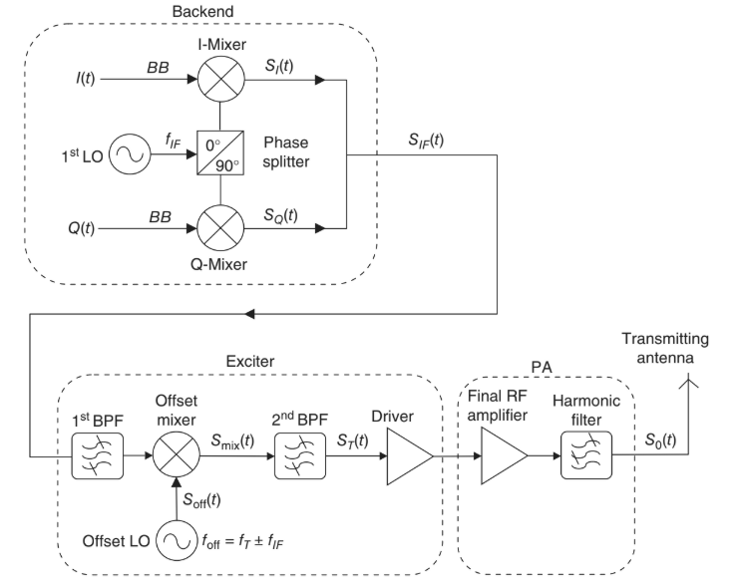
Figure 2.6 From Wireless Transceiver Design

I(t) and Q(t) baseband signals are commonly generated by local DSP. The signal from the Exciter is amplified by the PA and cleaned through the harmonic filter before being transmitted through the antenna.

Direct Launch Transmitter:
Commonly used to deliver broadband data with mid-level performance specs. Commonly used in Bluetooth and WiFi applications. Work well with integration. DLT operation is similar to the TSCT but does not utilize an Exciter stage.
The LO in the backend must be set directly to the transmit frequency. I and Q mixers must be able to operate at final frequency. Backend spurs and harmonics must be kept low. Careful layout and shielding will be required to keep injection locking from occurring.

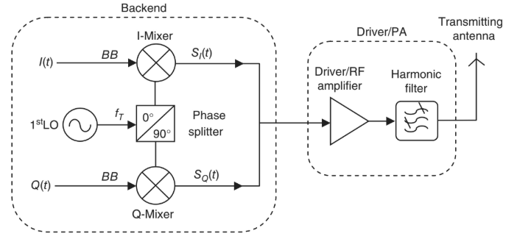
Figure 2.8 From Wireless Transceiver Design

Standards:
WPAN’s are standardized by the IEEE802.15 group. This group is divided into the following four main task groups.
- Task Group 1 (TG1) is devoted to standards for Bluetooth operating in the 2.4 GHz unlicensed ISM (Industrial, Scientific, and Medical) band.
- 2) Task Group 1 (TG2) is devoted to the coexistence of devices that operate in unlicensed spectra.
- 3) Task Group 3 (TG3) is devoted to high data rate WPAN standards, that is UWB (Ultra Wide Band) WPAN.
- 4) Task Group 4 (TG4) is devoted to a low data rate, low power WPAN standards.

Sources: Luzzatto, A. and Haridim, M. (2016). Introduction. In Wireless Transceiver Design (eds A. Luzzatto and M. Haridim). https://doi.org/10.1002/9781119315650.ch1

